Technical Datasheet Input / Output Modules with Modbus RTU Protocol with RS485 Interface

The IO modules communicate via RS485. The port can drive distances up to max 700 meters without the use of any repeater (this feature however also depends on the signal strength of the Modbus Master Device).
The RS485 Digital IO module is sturdy, low power usage and easy to use.

4 Port 4 DI + 1 DO Module: -

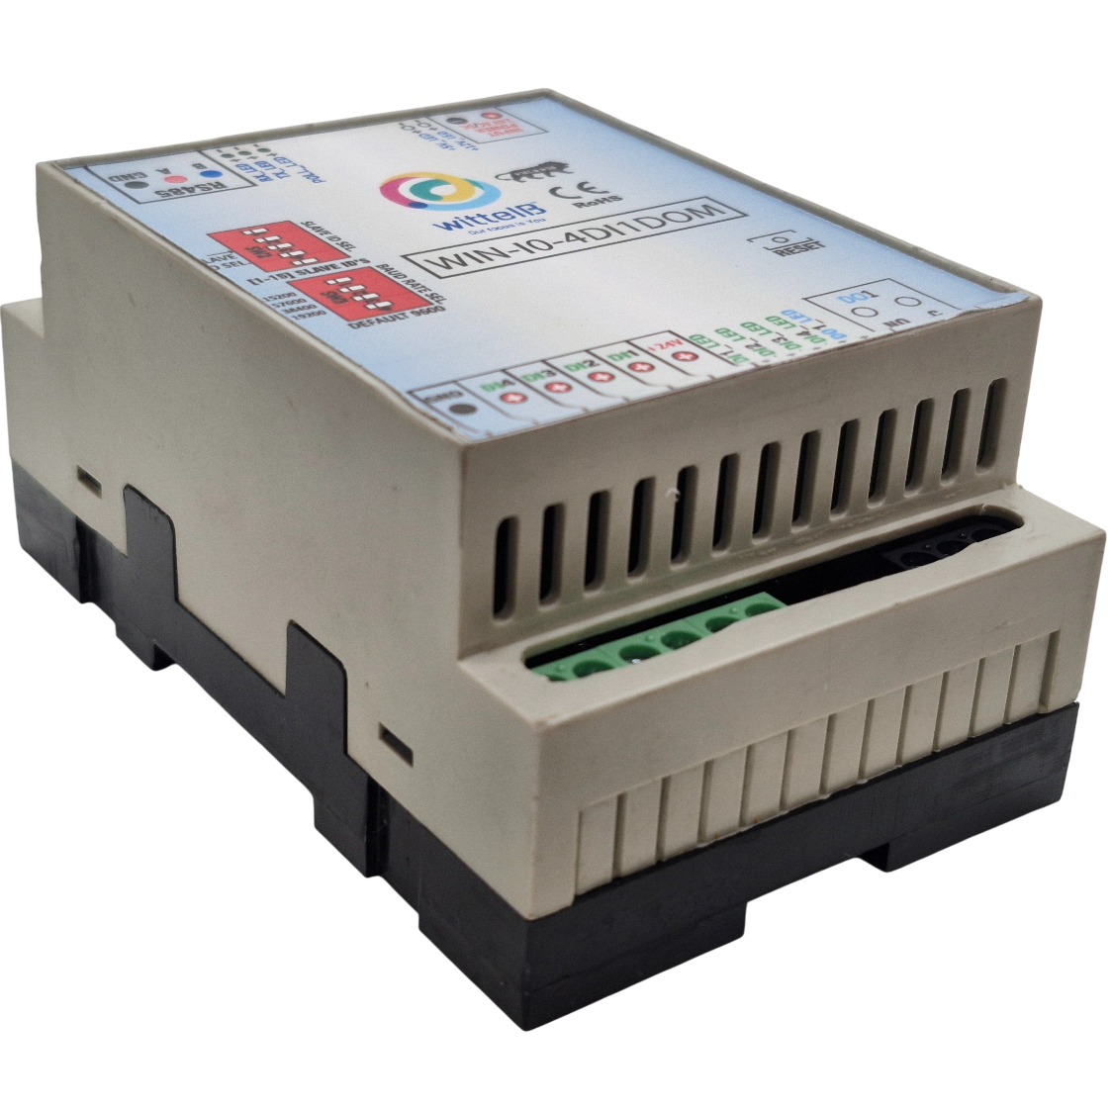
The IO modules are mounted on DIN rail mountable casing and with exposed connectors and LED indicators. The DIP switch for Slave ID and Baud rate are placed inside the enclosure.

The design of the modules incorporates ‘resettable Fuses’ to safeguard against reverse polarity connection both for Power and Communication port.

Specifications
General –
I/O Connectors 12 Pin 5.08 mm pitch pluggable screw Terminal Block, 2 Pin 5.08 mm pitch pluggable screw terminals.
Dimensions 110 mm L x 70 mm B x 50 mm H
Power Input Power – 12 - 24 VDC or V 24 AC/DC
Typical – 12V DC @ 110mA
Operating Temperature 0 – 60° C (32 ~ 140°F)
Storage Temperature -20 - 70° C (-4 ~ 158°F)
Storage Humidity 5 ~ 95 % RH, non – Condensing
Certifications 

DI Inputs –
Channels 4
Sense Voltage 3.3 – 30 VDC
Sense Logic Logic ‘0’ = <1 VDC, Logic ‘1’ = >3.3 VDC
Isolation Optically isolated
Response Time 2 msec, Max 6 msec

Relay Output –
Channels 1
Contact Form 1A, 1C
Contact Material Ag Alloy
Contact Capacity 10A @ 240VAC, 10A @ 28VDC
Coil Voltage 5 – 48 VDC
Coil Power 0.36 W
Insulation Resistance 250MΩ
Electrical Life 1 x 10^5
Mechanical Life 1 x 10^7
Operating Time 7 msec, Max 15 msec
Release Time 2 msec, Max 6 msec

Note: -
For MODBUS communications, a shielded and twisted pair cable is used. One example of such cable is Belden 3105A.
Additional Features: -
Communication port isolated
Input power reverse polarity safety
ESD Safety IEC 61000-4-2, ± 30KV contact, ± 30KV air
EFT IEC 61000-4-4, 50A (5/50ms)
750V isolation.
CRC Error check.
No configuration needed on the IO board

Configuration Settings: -
Communication Speed 9600 – 115200 (DIP SW selectable)
Data Bits 8
Parity None
Stop bit 1
CRC Yes
Slave ID 1 – 15 (DIP SW selectable)
Function code DI 0x02 Read discrete Input
DI Register Address 1,2,3,4.
Function code 0x05 and 0x0F (5 Single coil & 15 multiple coil)
DO Register Address 0.
Recommended Cable Electrical Characteristics: -
22 AWG Cable Shielded and twisted pair should be used.
Tinned Copper Recommended
Nominal Conductor DCR 14.7 ohm / 1000 ft
Nominal Capacitance 11 pf / feet (conductor to conductor)
High Frequency Non-Insertion Loss 0.5db / 100ft

ID | Function  Description | Register  Description | Modbus Function Code | Protocol | Data  Type
1 | DO 1 | 00001 | 0X05,0X0F | RS485 | 1 Bit Boolean
2 | DI 1(With & Without Potential) | 10002 | 0X02 | RS485 | 1 Bit Boolean
3 | DI 2(With & Without Potential) | 10003 | 0X02 | RS485 | 1 Bit Boolean
4 | DI 3(With & Without Potential) | 10004 | 0X02 | RS485 | 1 Bit Boolean
5 | DI 4(With & Without Potential) | 10005 | 0X02 | RS485 | 1 Bit Boolean

DI

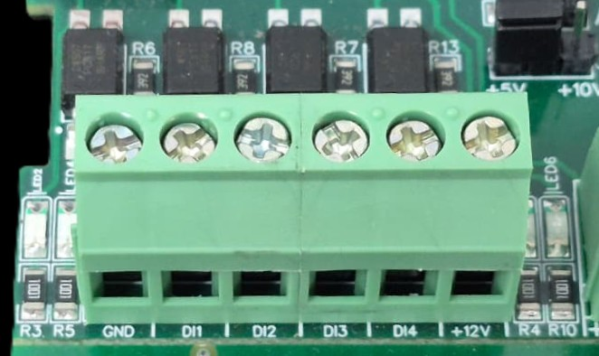

I/p device
I/p device
I/p device

I/p device

- Operation: The module provides four isolated input channels (DI1–DI4) for sensing external signals or dry contacts. These inputs are opto-isolated for circuit protection.
- Terminal Layout:
  - GND: Common Ground reference.
  - DI1 – DI4: Individual Digital Input channels.
  - +12V: Internal reference voltage for sourcing "Dry Contact" switches.
- Wiring Options:
  - Dry Contact: Connect a switch between the +12V terminal and any DI pin.
  - External Voltage: Connect the external signal to a DI pin and the external ground to the GND terminal.
- Voltage Rating: The input circuitry is rated for a maximum of 80VDC. Ensure external signals do not exceed this limit to prevent damage to the isolation ICs.

DO

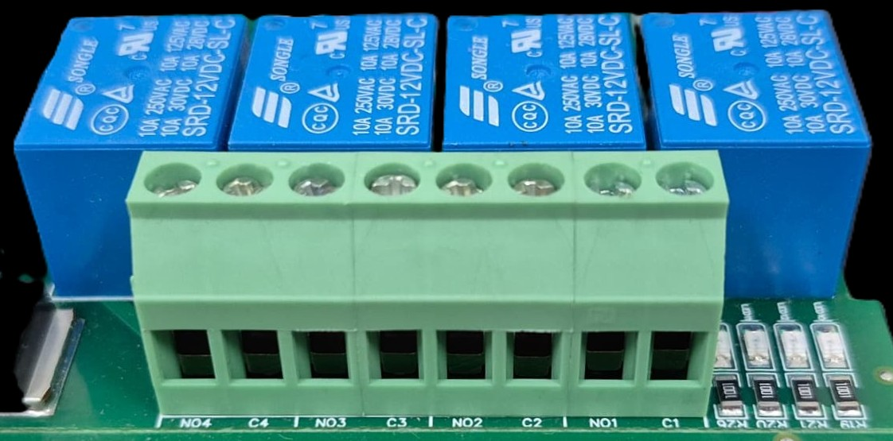





L
O
A
D
N

P
L
O
A
D
N

P
L
O
A
D
N

P
L
O
A
D
N

P

- Digital Output (DO) operation: Each channel provides two terminals: C (Common) and NO (Normally Open). When the relay coil is energized, terminal C is internally connected to NO, allowing current to flow. When the relay is de-energized, the connection between C and NO remains open, and the load stays OFF.
- Load Wiring Connections:
  - AC Load Connection: The AC Live (Phase) wire should be connected to terminal C. The load is connected between terminal NO and Neutral (N).
  - DC Load Connection: The positive supply (+V) should be connected to terminal C. The load is connected between terminal NO and Ground (GND).
- Crucial Safety Recommendation and Rating: It is strongly recommended to switch the Live (Phase) conductor in AC applications to ensure the load is safely de-energized when the relay is off.
Note: Ensure that the connected load does not exceed the relay’s contact rating of 10A @ 250VAC (or 10A @ 125VAC) or 10A @ 30VDC (or 10A @ 28VDC).

SLAVE ID DESCRIPTION
MSB
LSB
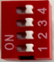

For Slave ID Selection SW is used to Set The SLAVE ID .
For Slave ID DIP Switch LSB is “1” follow through “4” is MSB.
Slave ID Confirmed through below Device ID table .
IF Eg. Slave ID 1 is Needed to be selected Switch number 1 should pulled up other three should be selected down side. So”1 0 0 0” will be selected as Slave ID 1.

Slave ID | DIP SWITCH |  |  |  | OUTPUT (Binary) | OUTPUT (Decimal)
 | 1 | 2 | 3 | 4
0 | OFF(0) | OFF(0) | OFF(0) | OFF(0) | 0 0 0 1 | 1
1 | ON(1) | OFF(0) | OFF(0) | OFF(0) | 0 0 0 1 | 1
2 | OFF(0) | ON(1) | OFF(0) | OFF(0) | 0 0 1 0 | 2
3 | ON(1) | ON(1) | OFF(0) | OFF(0) | 0 0 1 1 | 3
4 | OFF(0) | OFF(0) | ON(1) | OFF(0) | 0 1 0 0 | 4
5 | ON(1) | OFF(0) | ON(1) | OFF(0) | 0 1 0 1 | 5
6 | OFF(0) | ON(1) | ON(1) | OFF(0) | 0 1 1 0 | 6
7 | ON(1) | ON(1) | ON(1) | OFF(0) | 0 1 1 1 | 7
8 | OFF(0) | OFF(0) | OFF(0) | ON(1) | 1 0 0 0 | 8
9 | ON(1) | OFF(0) | OFF(0) | ON(1) | 1 0 0 1 | 9
10 | OFF(0) | ON(1) | OFF(0) | ON(1) | 1 0 1 0 | 10
11 | ON(1) | ON(1) | OFF(0) | ON(1) | 1 0 1 1 | 11
12 | OFF(0) | OFF(0) | ON(1) | ON(1) | 1 1 0 0 | 12
13 | ON(1) | OFF(0) | ON(1) | ON(1) | 1 1 0 1 | 13
14 | OFF(0) | ON(1) | ON(1) | ON(1) | 1 1 1 0 | 14
15 | ON(1) | ON(1) | ON(1) | ON(1) | 1 1 1 1 | 15

SLAVE ID DESCRIPTION
MSB
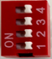
LSB

- For Baud rate Selection, DIP SW is used as per the diagram.
- Pulling up the switch will make Baud rate active.
- If no selection is made 9600 will be default Baud rate.
- When u change the Baud rate in the Module power ‘ON’ condition,
pls press the reset button to get Change to affect.

Baud Rate | DIP SWITCH
 | 1 | 2 | 3 | 4
9600 | OFF | OFF | OFF | OFF
19200 | ON | OFF | OFF | OFF
38400 | OFF | ON | OFF | OFF
57600 | OFF | OFF | ON | OFF
115200 | OFF | OFF | OFF | ON

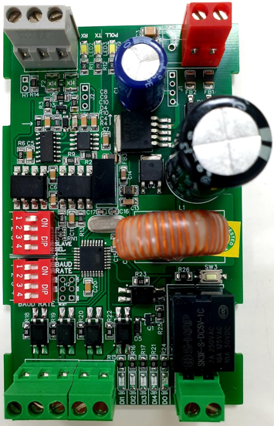
1 DO Port
DI4 DI3 DI2 DI1
DI Inputs
MSB
LSB
SLAVE ID
Modbus RS485
Input 24 AC-DC
+12 V DI Ref
BAUD RATE
LSB
MSB

Contact us: -
Augmatic Technologies Pvt. Ltd.,
Plot no 6, Shah Industrial Estate II,
Kotambi,
Vadodara – 391510.
Email – Sales@wittelb.com
Support: support@wittelb.raiseaticket.com / +91 94038 92805

